Assignment 3 Output

Endpoint:

<http://dev.cs.smu.ca:8099/Assignment3_webClient/sampleServiceclassProxy/TestClient.jsp?endpoint=http://dev.cs.smu.ca:8099/Assignment3_web/services/Serviceclass>

Screenshots:

**Get ALL transaction**

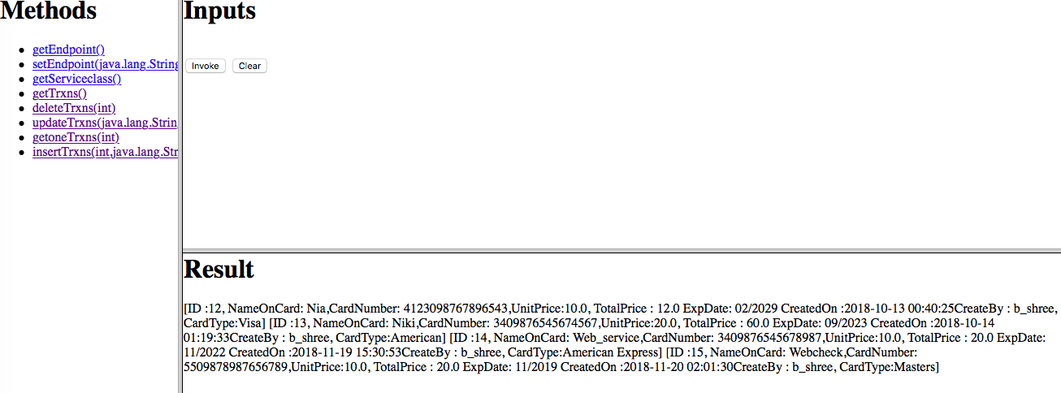

**getOne transaction:**

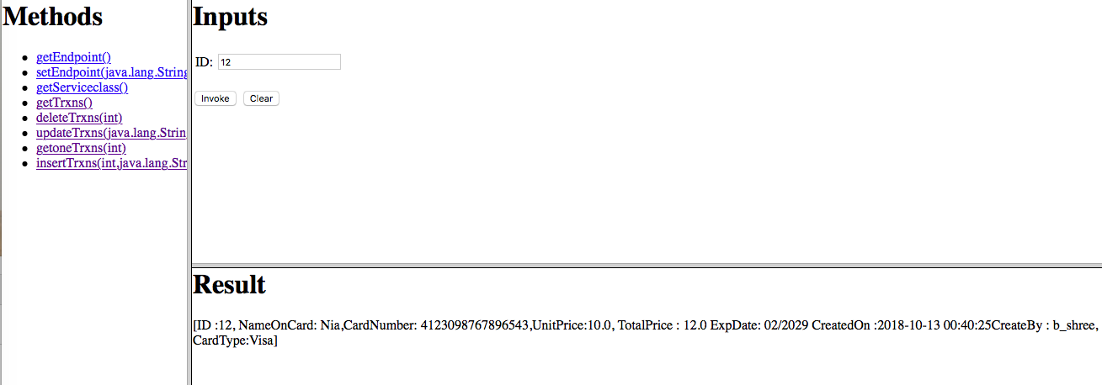

**Delete Transaction:**

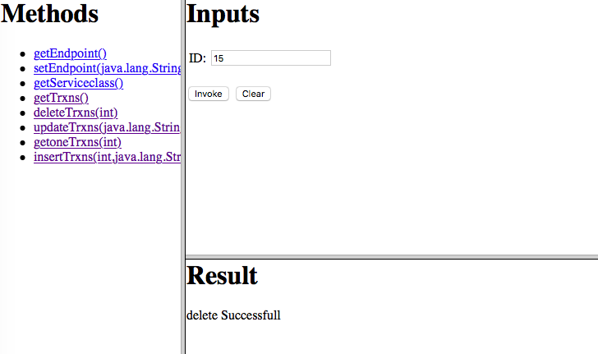

**Update Transaction:**

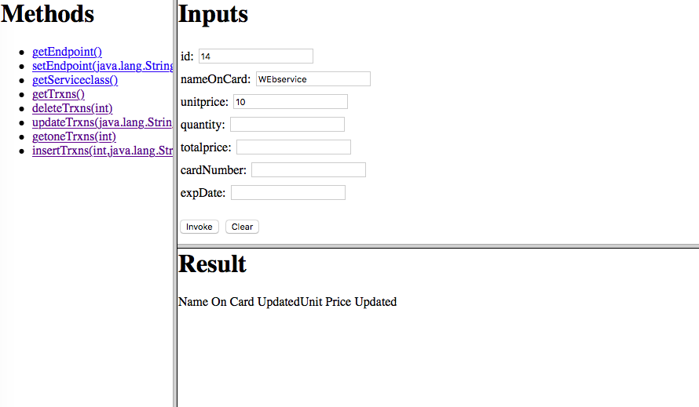

**Insert Transaction**

